Báo cáo thực hành

Lập trình hướng đối tượng

Thứ 7, 28/09/2024

**Exercise 1: Write, compile and run the ChoosingOption program:**

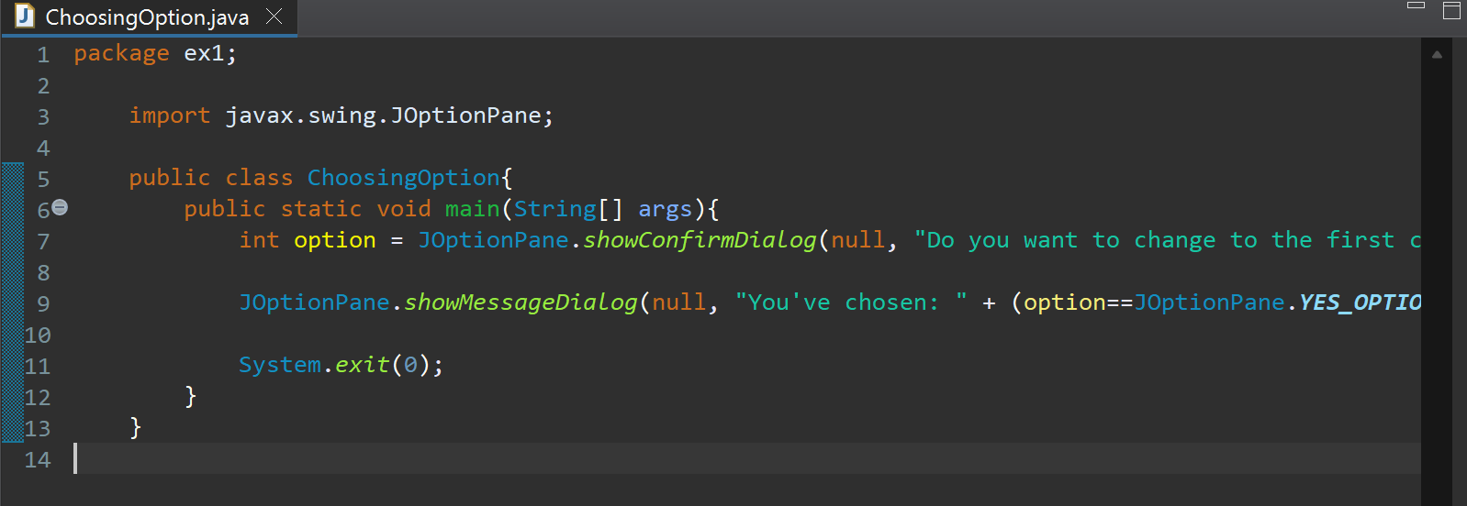

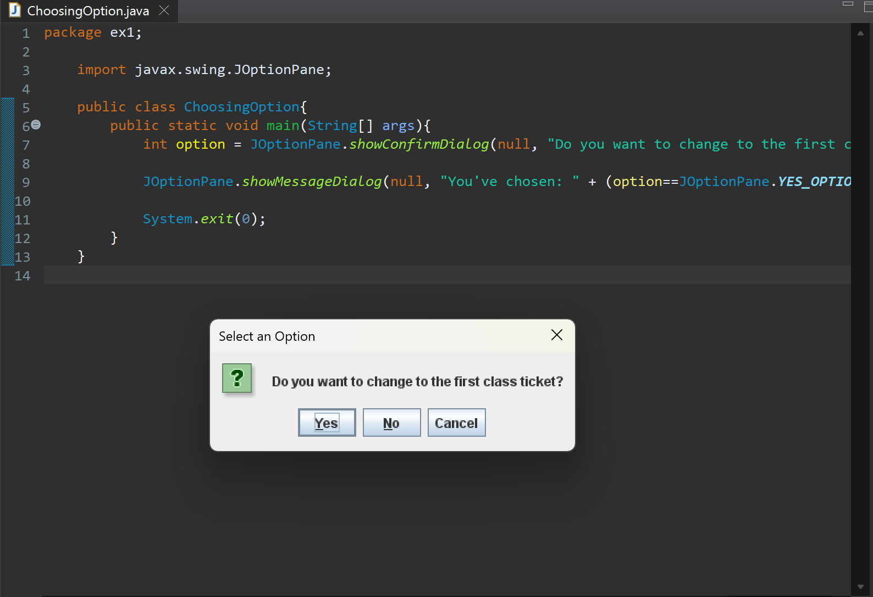

Questions:

- What happens if users choose “Cancel”: A message box appear and say that “You’ve chosen: NO”

- How to customize the options to users, e.g. only two options: “Yes” and “No”, OR “I do” and “I don’t” (Suggestion: Use Javadocs or using Eclipse/Netbean IDE help):

1. Use JOptionPane.showOptionDialog to create a dialog with custom options.

2. Define the options you want to display.

3. Handle the user's choice accordingly.

**Exercise 2: Write a program for input/output from keyboard**

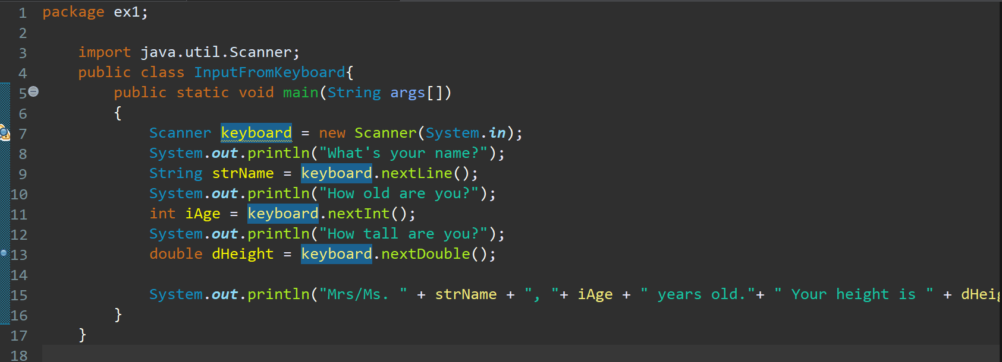

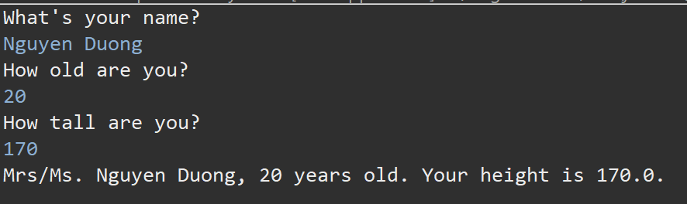

**Exercise 3: Write a program to display a triangle with a height of n stars (*), n is entered by users.**

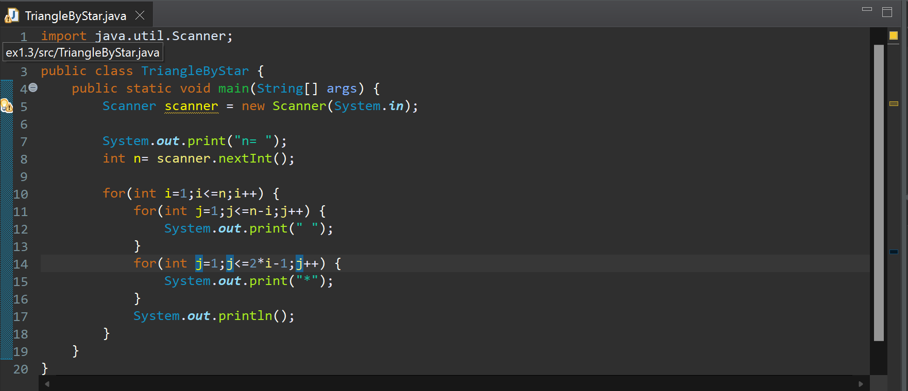

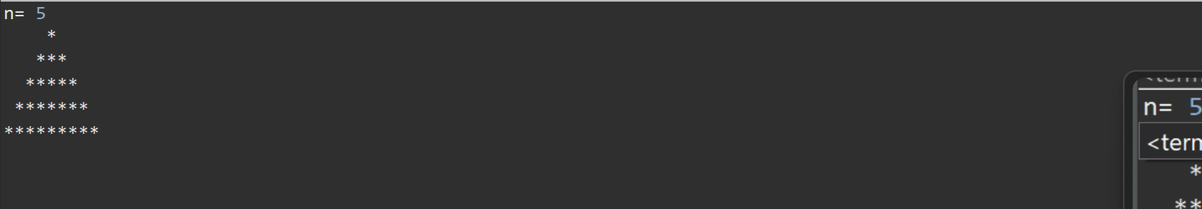

**Exercise 4: Write a program to display the number of days of a month, which is entered by users (both month and year). If it is an invalid month/year, ask the user to enter again.**

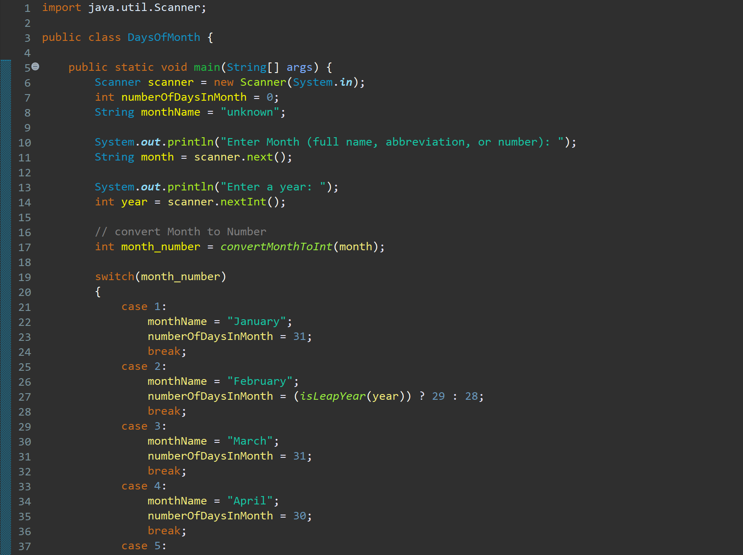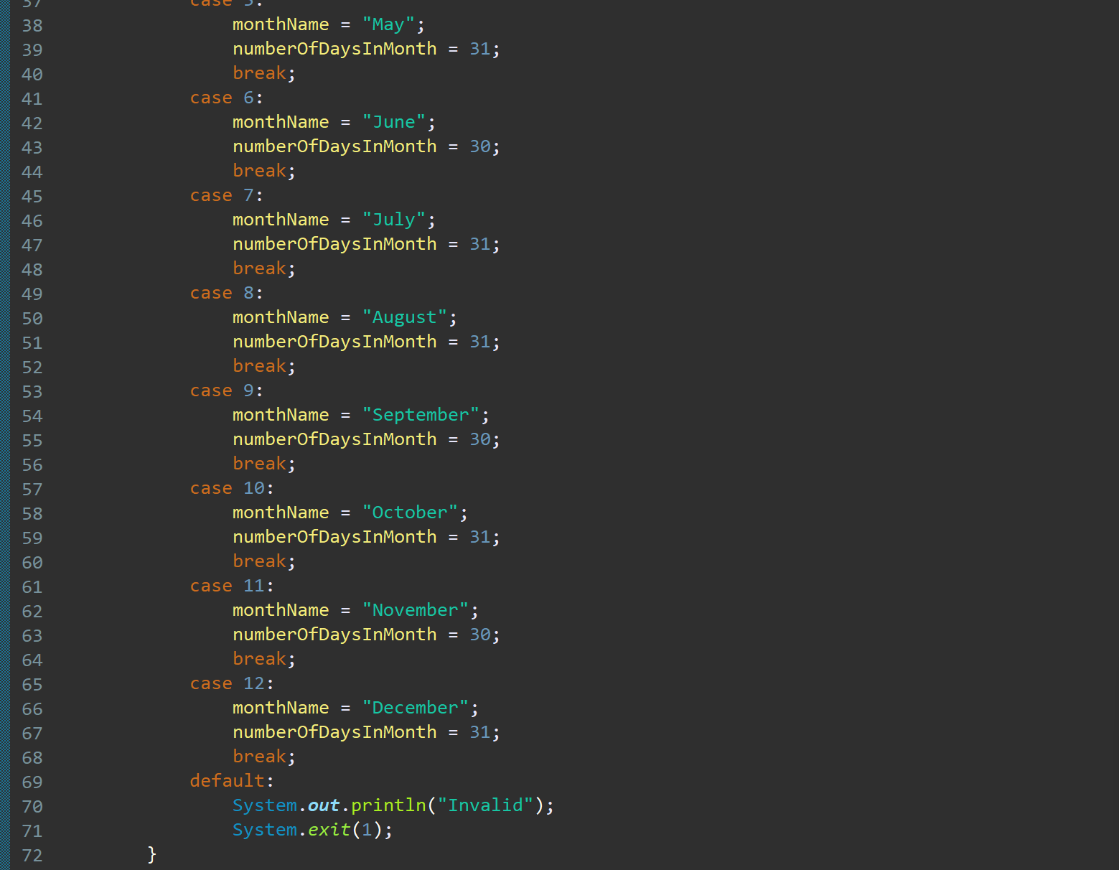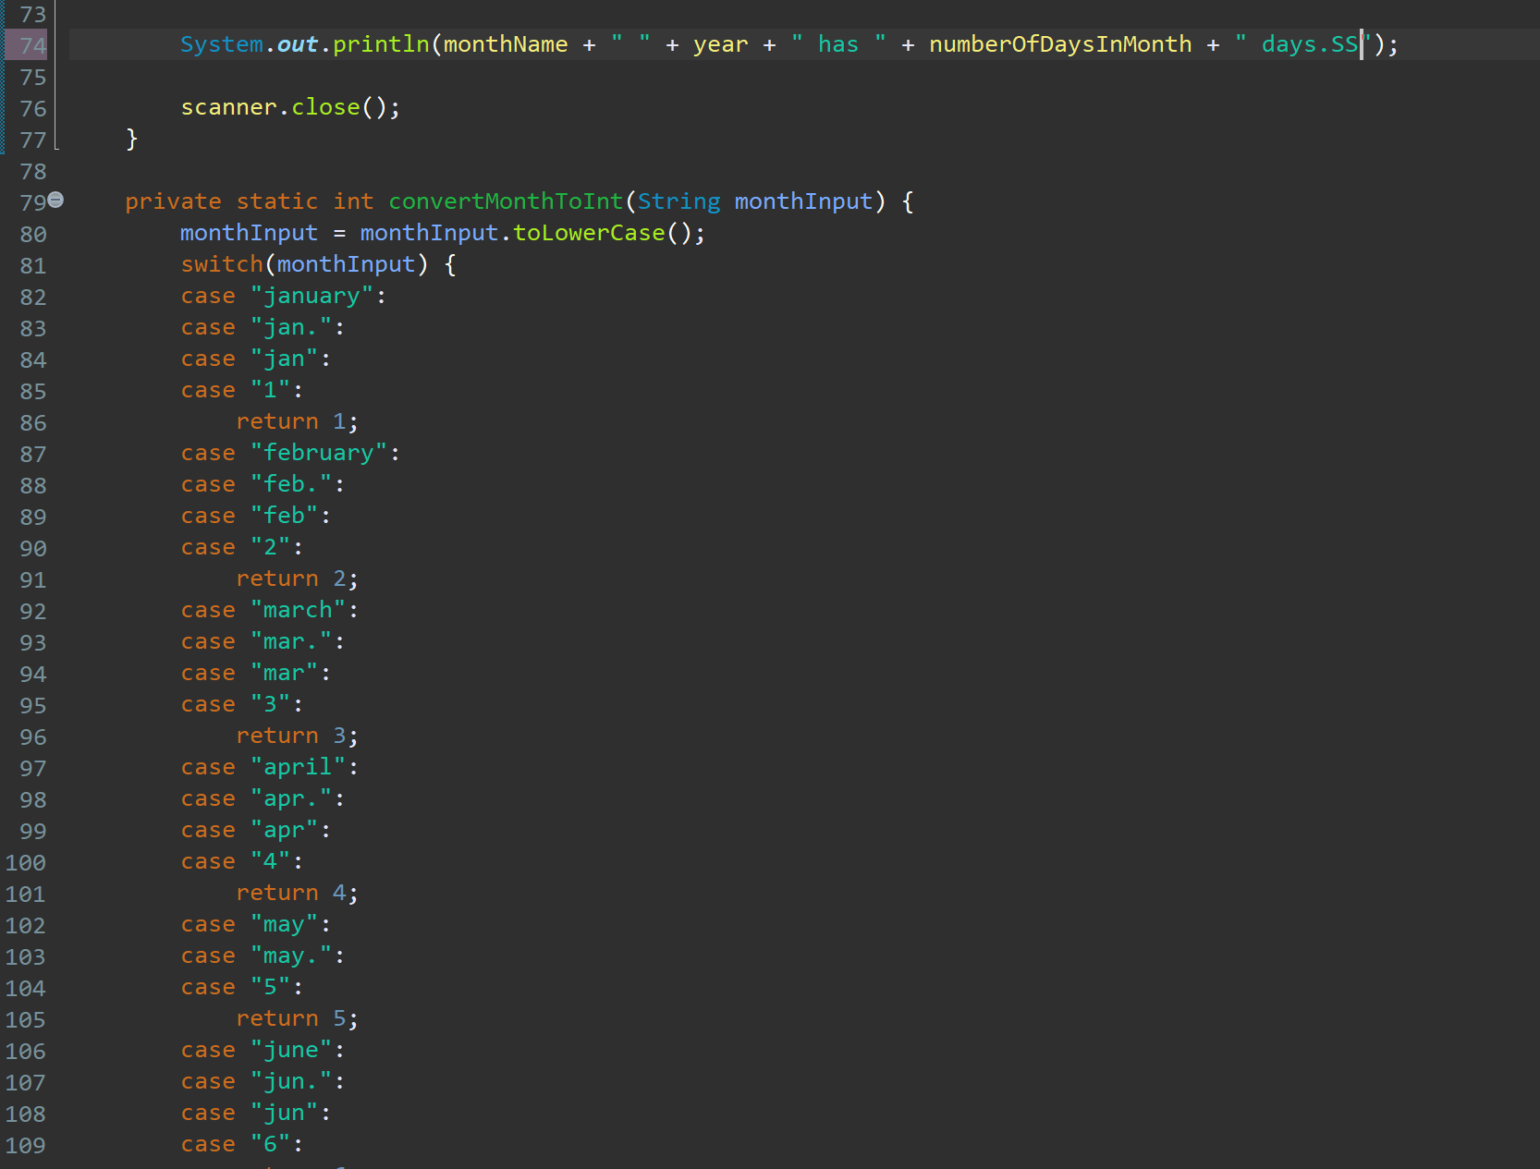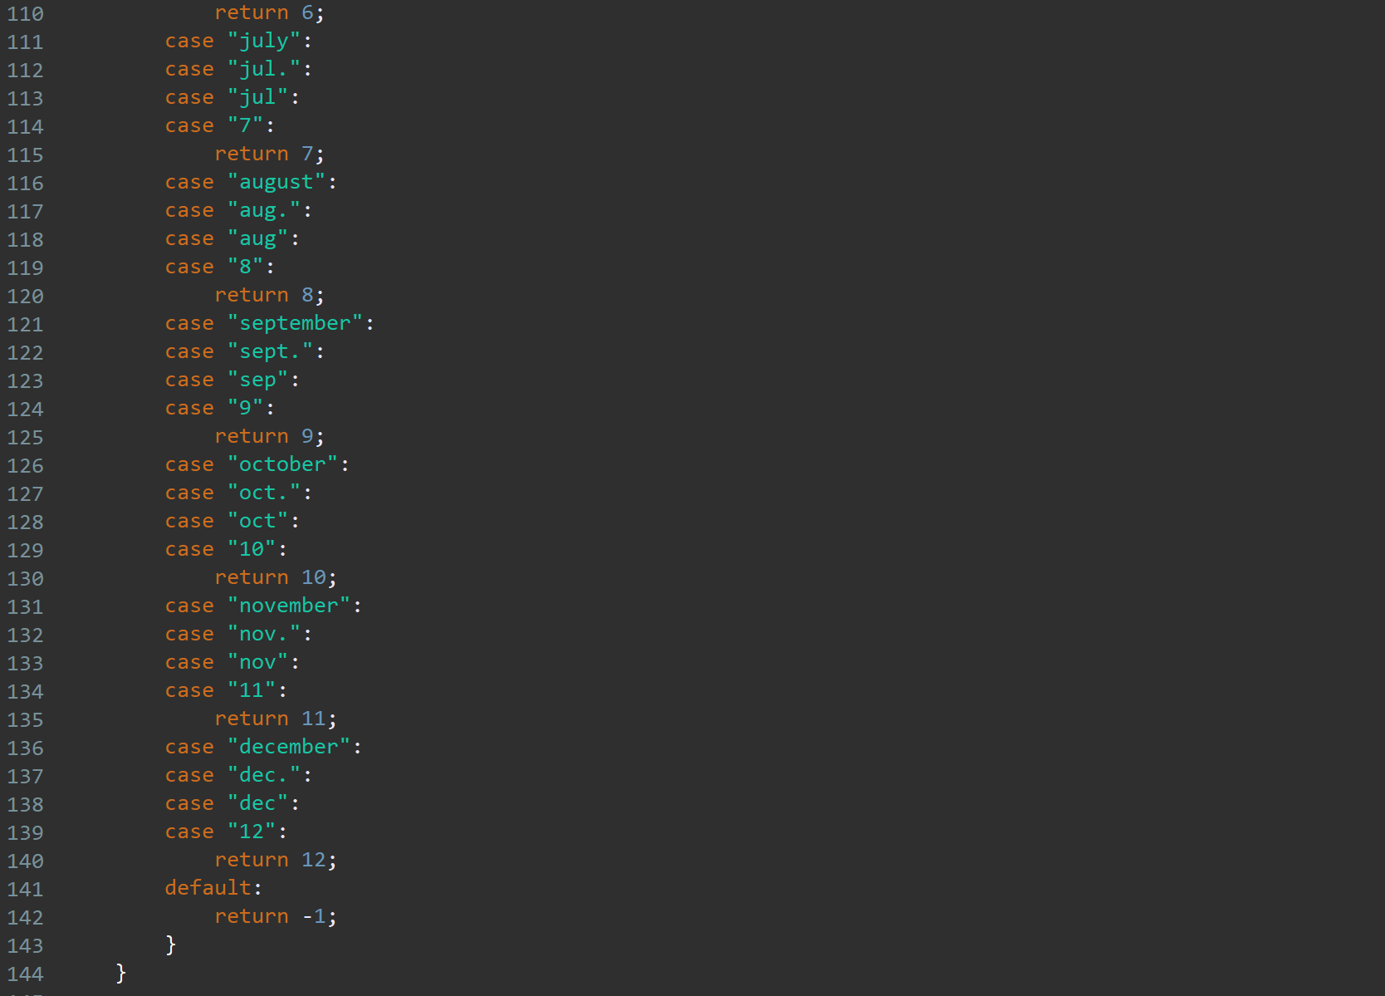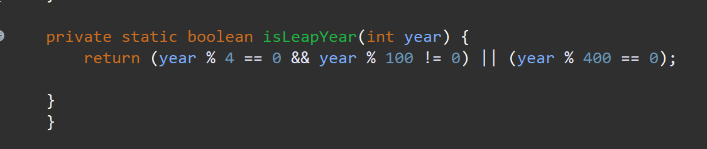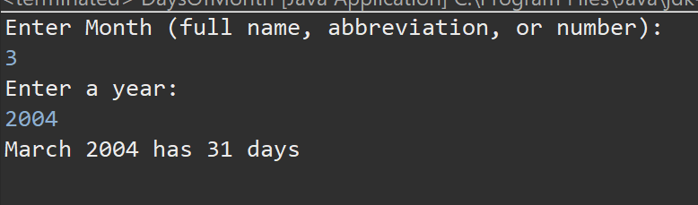

**Exercise 5: Write a Java program to sort a numeric array, and calculate the sum and average value of array elements.**

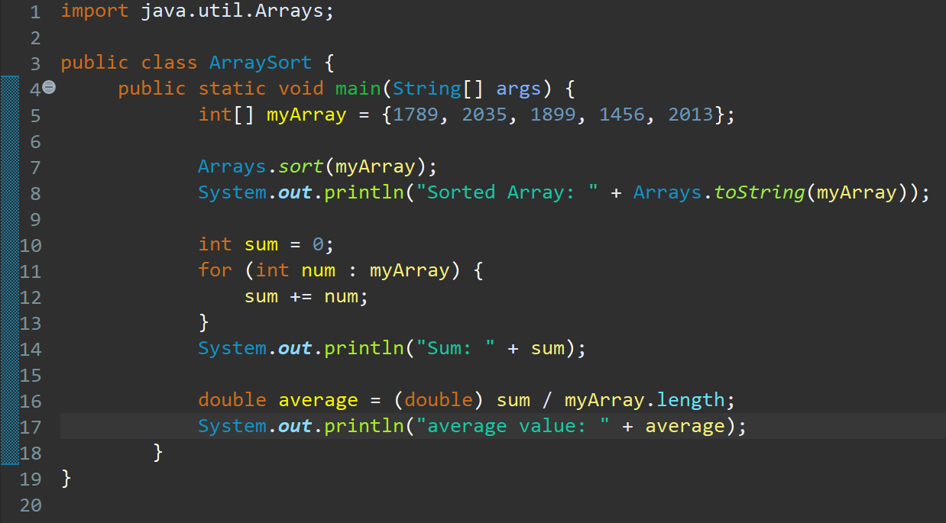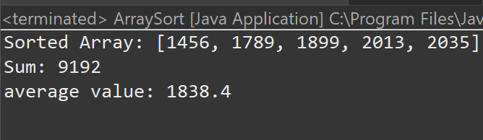

**Exercise 6: Write a Java program to add two matrices of the same size.**

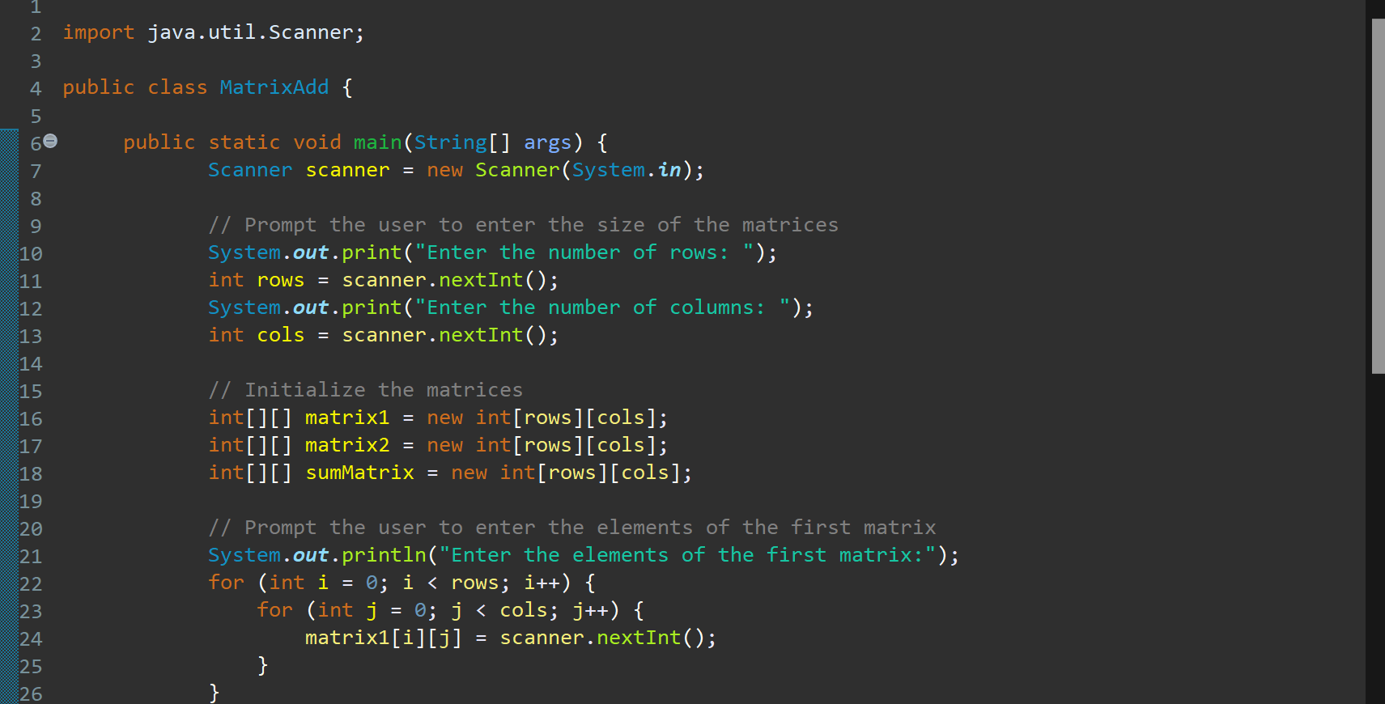

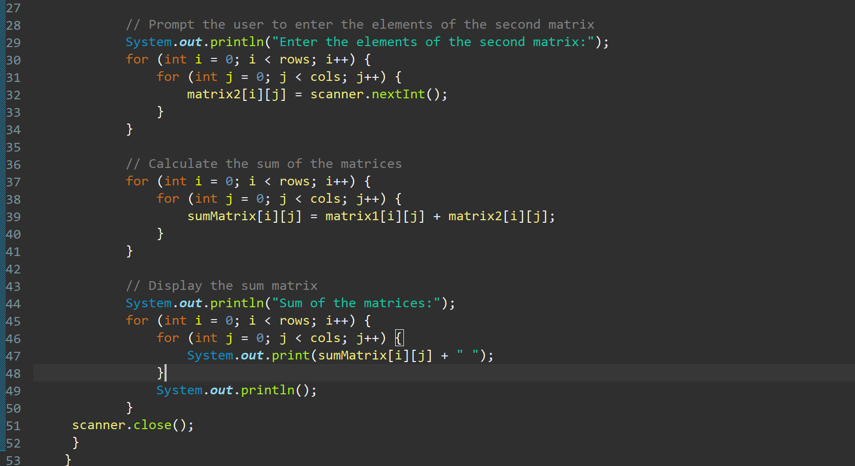

Result:

